Practical 4
Aim:- Use function types ,scope , and closure; apply try catch ;build a palindrome checker
Software/Tools Required: VS Code , Web Browser
Experiment program code:
Palindrome checker:-

<!DOCTYPE html>
<html lang="en">
<head>
<meta charset="UTF-8">
<meta name="viewport" content="width=device-width, initial-scale=1.0">
<title>Palindrome Checker</title>
<style>
body {
font-family: Arial, sans-serif;
background: #f4f4f4;
text-align: center;
margin-top: 50px;
}
.container {
width: 350px;
margin: auto;
background: white;
padding: 20px;
border-radius: 10px;
box-shadow: 0 0 10px gray;
}
input {
width: 90%;
padding: 10px;
margin: 10px;
}
button {
padding: 10px 20px;
cursor: pointer;
}
h3 {
color: blue;
}
</style>
</head>
<body>

<div class="container">
<h2>Sanvi Wadhankar 24070521191</h2>
<h2>Palindrome Checker</h2>

<input type="text" id="word" placeholder="Enter a word">

<button onclick="checkPalindrome()">Check</button>

<h3 id="result"></h3>
</div>

<script>

// Global Scope
let appName = "Palindrome Checker";

// Function Declaration
function cleanString(str) {
return str.toLowerCase().replace(/[^a-z0-9]/g, "");
}

// Function Expression
const reverseString = function(str) {
return str.split("").reverse().join("");
};

// Closure
function counter() {
let count = 0;

return function() {
count++;
return count;
};
}

const checkCount = counter();

// Arrow Function
const isPalindrome = (str) => {
return str === reverseString(str);
};

// Main Function
function checkPalindrome() {

try {

let input = document.getElementById("word").value;

// Local Scope
let text = cleanString(input);

if (text === "") {
throw "Please enter some text.";
}

let result = isPalindrome(text)
? `"${input}" is a Palindrome ✅`
: `"${input}" is NOT a Palindrome ❌`;

result += `<br>Checks Performed: ${checkCount()}`;

document.getElementById("result").innerHTML = result;

} catch(error) {

document.getElementById("result").innerHTML =
`<span style="color:red;">Error: ${error}</span>`;

}

finally {
console.log(appName + " executed.");
}
}

</script>

</body>
</html>

Output:-
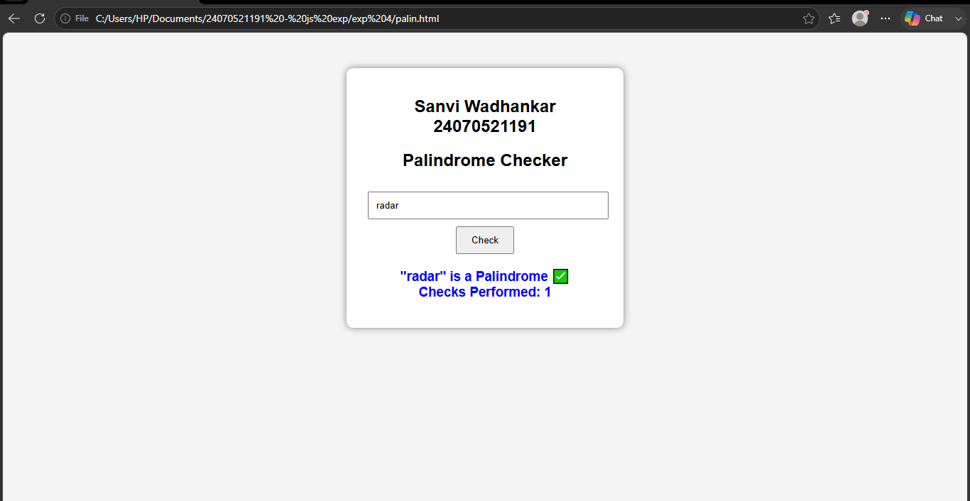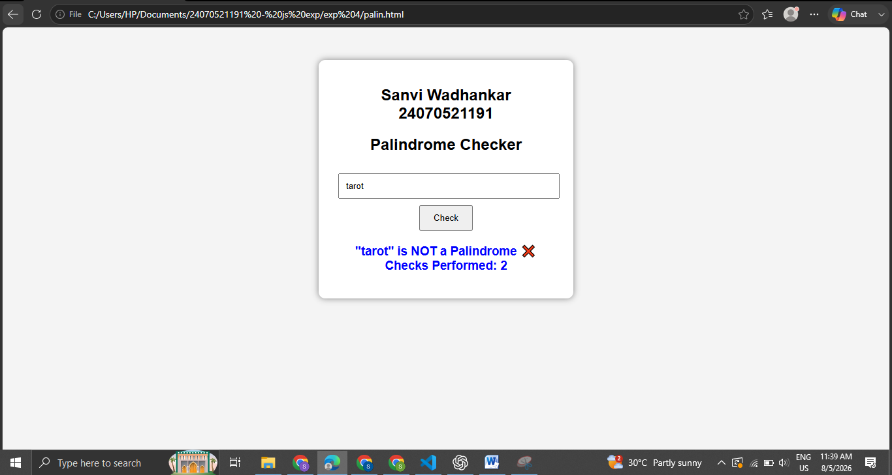

Case Study 04
Real-Time Case Study: ATM Card PIN Verification Using JavaScript Functions
Case Study An ATM system verifies whether a customer's PIN is a palindrome. If the PIN reads the same forward and backward, the bank displays a special security message. To implement this, create a function to reverse the entered PIN number and another function to check whether it is a palindrome. Use function declaration, function expression, arrow function, and demonstrate scope concepts
Software/Tools Used:- VScode , Web Browser
Case Study Code:-
<html>
<head>
<title>ATM PIN Verification</title>
<style>
body {
font-family: Arial, sans-serif;
background-color: #f2f2f2;
text-align: center;
padding: 40px;
}
h2 {
color: #1a5cff;
margin: 5px 0;
}
input {
padding: 8px;
font-size: 15px;
margin-top: 10px;
border: 1px solid #ccc;
border-radius: 4px;
}
button {
display: block;
margin: 15px auto 0;
padding: 8px 20px;
font-size: 15px;
background-color: #1a5cff;
color: white;
border: none;
border-radius: 4px;
cursor: pointer;
}
button:hover {
background-color: #0d3fb0;
}
#result {
margin-top: 20px;
font-size: 17px;
color: #333;
}
</style>
</head>
<body>
<h2>Sanvi Wadhankar 24070521191</h2>
<h2>ATM Card PIN Verification</h2>
<h3>Enter your 6-digit PIN:</h3>
<input type='text' id='pin' maxlength="6"></input>
<button onClick="verifyPin()">Submit</button>
<p id='result'></p>

<script>
// FUNCTION DECLARATION
// Reverses the entered PIN
function reversePin(pin) {
return pin.split("").reverse().join("");
}

// FUNCTION EXPRESSION
// Checks whether the PIN is a palindrome (reads same forward and backward)
var isPalindrome = function(pin) {
var reversed = reversePin(pin); // uses the function declared above
return pin === reversed;
};

// ARROW FUNCTION
// Displays the security message based on the result
var getMessage = (palindromeCheck) => {
if (palindromeCheck) {
return "Security Alert: Your PIN is a palindrome!";
} else {
return "PIN verified. No special security message.";
}
};

// MAIN FUNCTION (called on button click)
// MAIN FUNCTION (called on button click)
function verifyPin() {
var pin = document.getElementById("pin").value; // local scope variable

if (pin == "" || pin.length !== 6 || isNaN(pin)) {
alert("Please enter a valid 6-digit PIN!");
return;
}

var reversed = reversePin(pin);
var palindromeCheck = isPalindrome(pin);
var message = getMessage(palindromeCheck);

// Alert user if the PIN is a palindrome
if (palindromeCheck) {
alert("⚠️ Security Alert!\nYour PIN is a palindrome.\nFor better security, please change your ATM PIN.");
}

document.getElementById("result").innerHTML =
"PIN entered = " + pin + "<br>" +
"Reversed PIN = " + reversed + "<br>" +
message;
}
</script>
</body>
</html>

Output:-
